ВСЕРОССИЙСКАЯ ОЛИМПИАДА ШКОЛЬНИКОВ АНГЛИЙСКИЙ ЯЗЫК. 2026–2027 уч. г.
ШКОЛЬНЫЙ ЭТАП. 5–6 КЛАССЫ

Максимальный балл за работу – 52.
LISTENING
Recommended time: 15 minutes (8 points)

Task 1
Linda and Chris are travelling with their parents around Russia. Right now they are in Moscow, in the Tretyakov Gallery. They are looking at different pictures and sharing their impressions with each other. Listen to their dialogues about each of the following pictures and guess which picture they are discussing. You will hear the dialogues twice. Now you have 1 minute to study the pictures.

Задание 1.
«Опять двойка», Фёдор Решетников
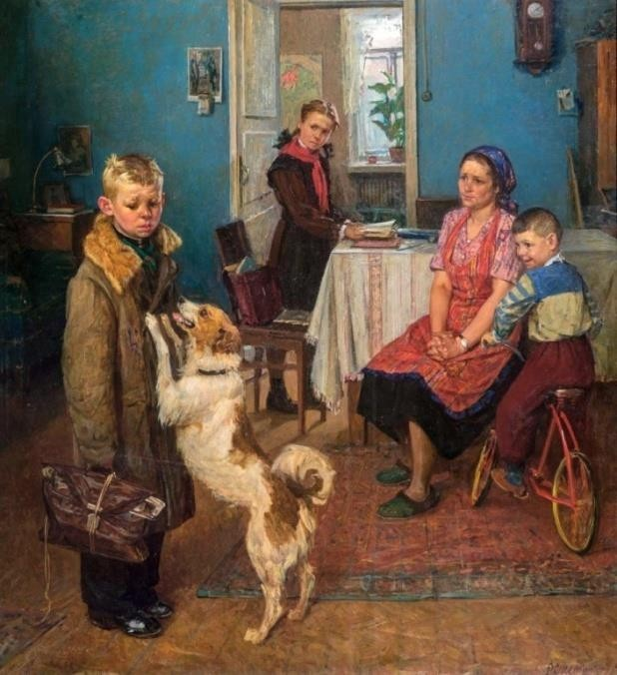
In which dialogue are the children talking about this picture?
Dialogue

«За завтраком», Зинаида Серебрякова
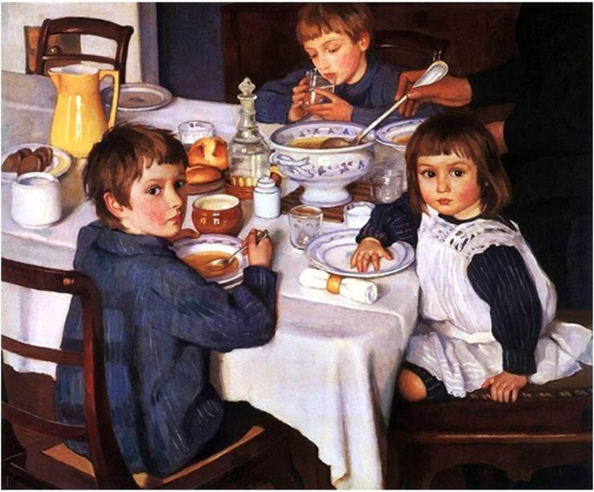
In which dialogue are the children talking about this picture?
Dialogue

Задание 3.
«Устный счёт в народной школе С. А. Рачинского», Николай Богданов-Бельский
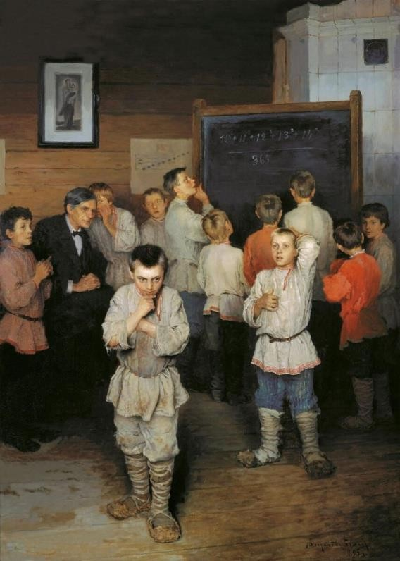
In which dialogue are the children talking about this picture?
Dialogue

«Тройка», Василий Перов
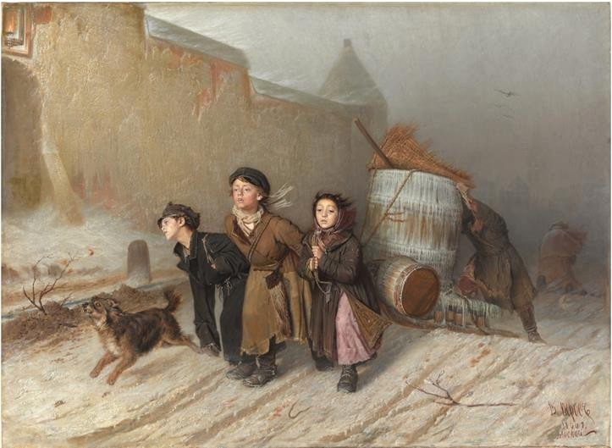

In which dialogue are the children talking about this picture?
Dialogue

Задание 5.
«Дети, бегущие от грозы», Константин Маковский
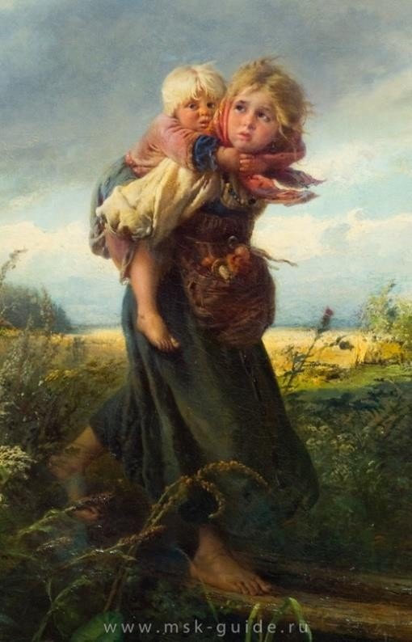
In which dialogue are the children talking about this picture?
Dialogue

«Крестьянские мальчики стерегут лошадей», Владимир Маковский
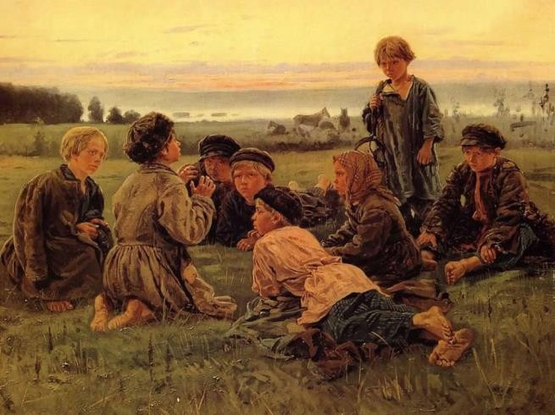

In which dialogue are the children talking about this picture?
Dialogue

Задание 7.
«Бабушкины сказки», Василий Максимов
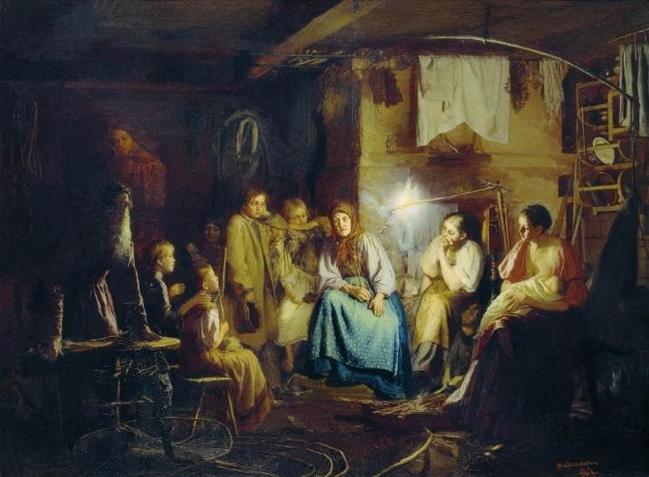
In which dialogue are the children talking about this picture?
Dialogue

Задание 8.
«Новенькая», Эмилия Шанкс
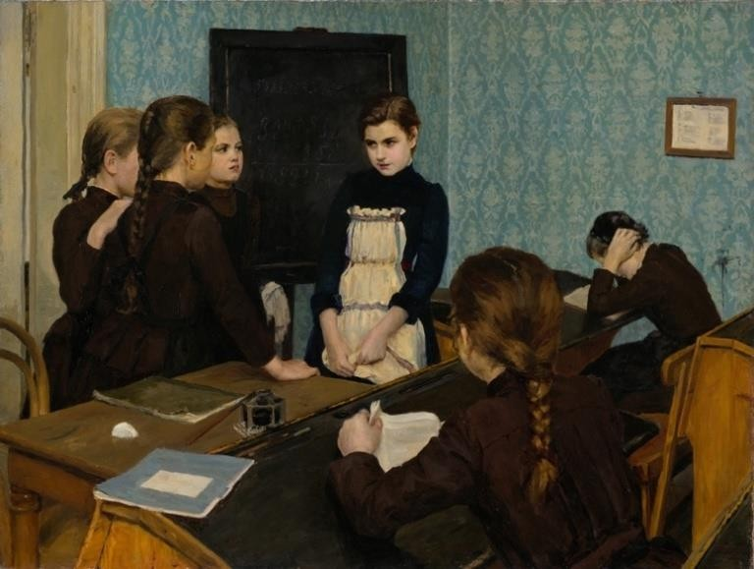
In which dialogue are the children talking about this picture?
Dialogue

READING
Recommended time: 10 minutes (9 points)
Задание 9.
Read the text below. Fill in the blanks 1-6 with sentences A-F.
I really love my room. (1) . Because it’s full of fantastic things and sounds. (2) . They shine in the dark. (3) . I also have a cage full of white mice. (4) . They are always more active at night than during the day. (5) . Sometimes I like to think I’m a monkey swinging and jumping from bunk to bunk. (6) .
- When I’m in bed, I imagine looking at the sky on a moonless night in a desert.
- Finally, my bunk bed is like a jungle gym.
- Can you guess why?
- I guess I’m pretty lucky to have such a cool room.
- For one thing, I have lots of plastic stars glued to my ceiling.
- At night, it’s comforting to hear them scratching in the cage.

1 | 2 | 3 | 4 | 5 | 6
Now answer the following questions:
Задание 10. Which title is the best for this text?
- White Mice Are the Best Pets
- Reasons Why I Like My Room
- Fantastic Things and Sounds

Задание 11. Which sentence is the best to finish this text with?
- No wonder my friends love visiting me and having sleepovers.
- To keep it cool, I always open the window at night to let in fresh air.
- I’m also lucky to live in a nice town and to have a great family.
Задание 12. From the text we know that in the room the author of the text has …
- at least one mouse.
- at least one monkey.
- a monkey and a mouse.

USE OF ENGLISH
Recommended time: 45 minutes (35 points)
Задание 13.
Task 1
Read the text below and choose the best answer for each space. The first one is done for you.

Example:
0 A) was looking B) looks C) look

Maggie’s Big Brother
Maggi got into bed, but she didn’t close her eyes. She (0) at her closet doors.
She was afraid. “I (1) to Blake again!” she thought.
Blake was (2) classmate. At school that afternoon he (3) Maggie that monsters lived in bedroom closets. Maggie knew it was not true because monsters
(4) . Right?
Maggie tried to (5) asleep.
Scratch! Scratch!
She jumped (6) bed and screamed, “A monster!”.
“No, it’s just me!” Connor said. “I (7) the cat’s box.” Connor was Maggie’s big brother. He was in middle school.
Maggie closed her eyes again.
Crunch! Crackle!
Maggie’s eyes opened. “What (8) ?” she cried.
“(9) again,” Connor said. “Mom told me to empty the wastepaper basket.”
A moment later, Connor came back to Maggie’s room. “(10) aren’t you asleep?” he asked.
“Because there are monsters in my closet!” Maggie said. “And why (11) in bed? Why are you cleaning the house so late?”
“I’m just helping Mum and Dad,” Connor said. Connor came up to Maggie’s closet and pointed at it with (12) finger.
“What are you doing (13) ?” Maggie asked.
“Shh!” Connor said. “I’m doing magic! Alakazee! Alakazam! Monsters go to Amsterdam! Now you (14) no monsters in your closet!”

Maggie started (15) . (16) was all so funny and silly – her fears and Connor’s magic! Why did she even listen (17) Blake? Connor came up to her bed. “Good night, Maggie,” he said, “See you (18) the morning”.
Maggie (19) stop laughing for a long time. But then she (20) about monsters. In five minutes she was sound asleep.

 | A | B | C
0 | was looking | looks | look
1 | will never talk | never talk | never talking
2 | Maggie | Maggie’s | Maggies
3 | tell | will tell | told
4 | didn’t exist | not exist | was not existing
5 | fall | jump | get
6 | without | out from | out of
7 | clean | am cleaning | cleaning
8 | that was | was that | it was
9 | I | my | me
10 | What | When | Why
11 | are you not | you are not | do you not
12 | her | his | he’s
13 | they’re | their | there
14 | will not have | will have | won’t have any
15 | laughing | laugh | was laughing
16 | These | Those | This
17 | --- | to | at
18 | on | --- | in
19 | can’t | couldn’t | could
20 | forget | to forget | forgot

Can you turn CAT into PET? Use the word descriptions to help you find the right words. Only the letter in the circle should change from one word to the next. The first three have been done for you.

 | The opposite of COLD | 
 | You wear it on your head | 
 | A meowing animal | 
Задание 14. | A night animal with wings | 
Задание 15. | The opposite of GOOD | 
Задание 16. | You sleep in it
Задание 17. | It makes honey | 
Задание 18. | Eyes do it
Задание 19. | A lot of salty water
Задание 20. | You “drink with jam and bread”
Задание 21. | 10
Задание 22. | One man, many…
Задание 23. | You write with it
 | A cat at somebody’s home | 

14 | 15 | 16 | 17 | 18 | 19 | 20 | 21 | 22 | 23

Place the words in the right order to make sentences.
There is an example done for you:

Example:
0. are in all the cats grey dark All cats are grey in the dark.
Задание 24. The dog her carries bag her lady in

Задание 25. forget birthday if sad be I will He his

Задание 26. my but books went I at school forgot home

Задание 27. for book you were the looking you find Did

Задание 28. scary am I afraid things of

